Consumer Care Book Tiger FC582x

Approved by:

CMM: Beril Ozkan,
(Sign off via PPIM)

Author: | Yvonne Dingsté
Date: | 29-11-2012
AKB: | AKB 32GV-120043 Consumer Care Book Bobcat FC
Version: | Final
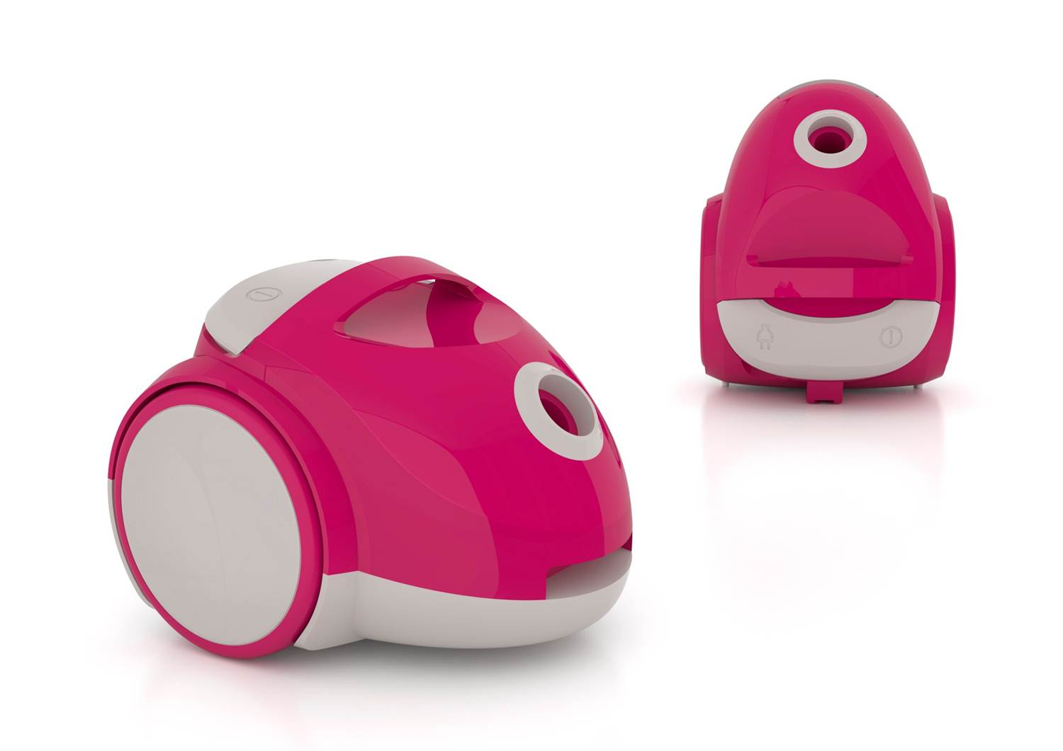

Product introduction

The IPD project Tiger will replace AirStar, with new proposals that focus on ease of use and superior cleaning performance. A new set of designs will be implemented to bring a modern and fresh look to our brand, while keeping competitiveness vs. key players. In China aim is to grow the core Q2/Q3 FC segments (bagless and bag) in China by 6m€ also key to improve the value share in China (bagless and bag) with ~4% in 2015 (from 34% to 38%)

The Bag price (Tiger) range will targeting half of the bag market (399-599RMB)

VPH
1. Target | 2. End-user Insight | 3. Competitive Environment
Harmony Creators [yellow]:  They look for cleanliness beyond a visible result, but with not too much effort (average). Their goal is to create an inviting atmosphere where everyone can feel welcome  Cleanliness, beyond visibly clean: High demand regarding a clean floor. Reached by average efforts and average to high frequency. The device itself gets proper care.  Focusing on being able to clean the floor in an easy way: Trustworthy, safe and durable. High suction power, which defines quality. Technology is believed to complement suctionpower. Flexible and thus easy to carry and reaching all difficult spots | "It is important to have a clean house. I do believe that vacuum cleaners can help me to clean my floors and better reach and clean difficult areas. However I find them too much of an effort to use and clean, they are bulky, heavy, and it is a hassle to change accessories.  I wish there was a vacuum cleaner that was easier to use.." | Panasonic MC-CA391 (59€ (GfK Mat):easy and convenient to use. 1510W input power and 400W claimed suction power. Clean corner nozzle and crevice tool.  Panasonic MC-CA293 (59€ (GfK Mat): It has standart nozzle and crevice tool.750W input power and 250W claimed suction power.
4. End- user benefit | 5. Reasons to Believe | 6. Discriminator
[Bobcat] makes vacuum cleaning easier. | This is because:  - It has a small integrated brush that is always at hand for easy handling  - It has a compact and streamlined design, that makes it easy to maneuver and store. | WOW: Tough on Dust, Easy on You  Sub-WOW: Compact and powerful, the easy way to clean ( WOW and Sub-WOW to be validated in consumer research)
Brand positioning : Describe how you (will) know for sure above proposition make consumers/customers consider this…
designed around you: | advanced: | easy to experience:
Due to its compact size for ease maneuvring and storage (space is a limitation). | Smart solutions to make vacuum cleaning easier. Easy to empty and clean dust-bag/bucket and an integrated brush. | Easy to use because the small integrated brush is always at hand. Easy to carry and maneuvre due to it compact design. Easy to clean because of the easy empty bucket/bag and streamlined design. Easy to store because of its compact design.

1. Target | 2. End-user Insight | 3. Competitive Environment
Harmony Creators [yellow]:  They look for cleanliness beyond a visible result, but with not too much effort (average). Their goal is to create an inviting atmosphere where everyone can feel welcome  Cleanliness, beyond visibly clean: High demand regarding a clean floor. Reached by average efforts and average to high frequency. The device itself gets proper care.  Focusing on being able to clean the floor in an easy way: Trustworthy, safe and durable. High suction power, which defines quality. Technology is believed to complement suctionpower. Flexible and thus easy to carry and reaching all difficult spots | "It is important to have a clean house. I do believe that vacuum cleaners can help me to clean my floors and better reach and clean difficult areas. However I find them too much of an effort to use and clean, they are bulky, heavy, and it is a hassle to change accessories.  I wish there was a vacuum cleaner that was easier to use.." | Panasonic MC-CA 491 (87€ (GfK Mat): easy and convenient to use.1510W input power and 400W claimed suction power.Rubber wheels. Clean corner nozzle and crevice tool to reach all areas.  Lexy VC-T3511E (78€ (GfK Mat): It has all purpose nozzle, sofa/flat nozzle, 1300W input power and 250W suction power.HEPA filter, soft wheels.
4. End- user benefit | 5. Reasons to Believe | 6. Discriminator
[Bobcat] makes vacuum cleaning easier. | This is because:  - The specially designed dust bucket allows you to empty and clean it in an easy and tidy way (bagless).  - It has a small integrated brush that is always at hand for easy handling  - It has a compact and streamlined design, that makes it easy to maneuver and store. | WOW: Tough on Dust, Easy on You  Sub-WOW: Compact and powerful, the easy way to clean ( WOW and Sub-WOW to be validated in consumer research)
Brand positioning : Describe how you (will) know for sure above proposition make consumers/customers consider this…
designed around you: | advanced: | easy to experience:
Due to its compact size for ease maneuvring and storage (space is a limitation). | Smart solutions to make vacuum cleaning easier. Easy to empty and clean dust-bag/bucket and an integrated brush. | Easy to use because the small integrated brush is always at hand. Easy to carry and maneuvre due to it compact design. Easy to clean because of the easy empty bucket/bag and streamlined design. Easy to store because of its compact design.

1. Target ` | 2. End-user Insight | 3. Competitive Environment
Advanced Perfectionists [Green]:  Strive for the perfect result. Clean the floor very often for perfect/immaculate floor. Use a VC for all kinds of tasks (also details).  Both process and result need to meet professional standards: High demand regarding a clean floor. Device needs to fulfill the basic expectations: high suction power, durable, high quality. This is highly importance.  Focusing on the result: Fast replacement cycle to continuously be a professional, triggered by loss of suction power and new technology | "For me it is important to have a clean house, therefore I am always looking for the best tools I do believe that vacuum cleaners can help me to clean my floors and better reach and clean difficult areas. However I find them too much of an effort to use and I am not always sure they remove all dust.  I wish there was a vacuum cleaner that was easier to use, ensuring the best result." | Philips is leader in MAT12 with 30.9% value share in the market. Panasonic is 2nd brand with 14.9% share. Panasonic claim is: Mini figure, big suction power. The most important competitor products for Tiger are:  MC CA-402 (93€ (GfK Mat): Easy and cenvenient to use, has hard&soft floor standart nozzle, crevice tool, 1510W input power and claim 400W suction power. MC-CA781 (142€ (GfK Mat): Powerful and compact with easy-to-decouple ionizing nozzle for better reach.Remote control on the handle. 1510W input power 450W claimed suction power. MC-CA783 (169€ (GfKMat). Easy and convenient to use (with remote control), powerful.1510W input power 450W claimed suction power. Lexy has 8.9% value market share in MAT, it increase its market share in bagless category. Lexy VC-T3513E-5 (136€ (GfK Mat): Efficient separation of dust particles (cyclone), has plenty of accessories for reaching into difficult areas, handle has remote control, extendable crevice tool.
4. End- user benefit | 5. Reasons to Believe | 6. Discriminator
[Tiger] gives you the best cleaning result in an easier way . | This is because:  - Power Cyclone™ technology collects and captures more dirt and dust in one go  - The specially designed dust bucket allows you to empty and clean it in an easy and tidy way  - It has a small integrated brush that is always at hand for cleaning difficult areas. | WOW: Powerful cleaning, beyond your floors (to be validated)  Sub-WOW: Advance PowerCyclone™ cleans even in difficult to reach areas, furniture and curtains. (WOW and Sub-WOW to be validated in consumer research)

Consumer care focus
For this product we carry out the standard consumer care package +
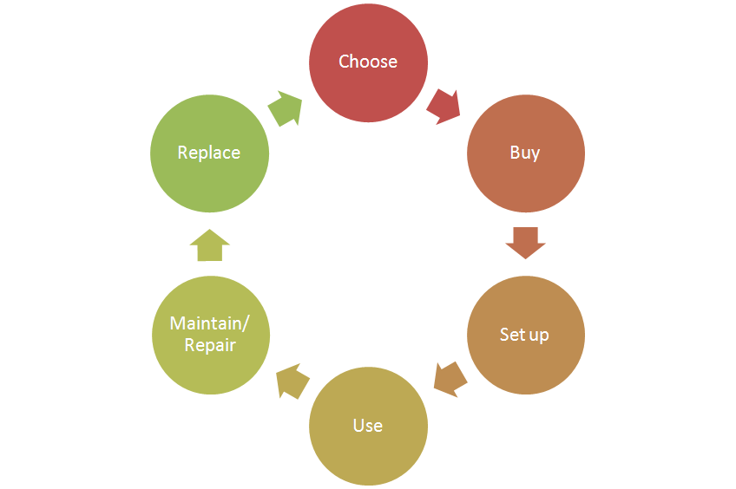
- Choose:
  - Support the “Making cleaning easier” theme
by clear communication of the key benefits.
- Buy:
- Setup:
  - Supporting the accessories included (list available accessories and
where to buy to enable consumer to upgrade)
- Use:
- Maintain/repair:
  - Product experience enhancement especially why, how to clean the filters,
where they are located and how to purchase.
- Replace:

CRM strategy:

Not planned.

Sales introduction and IPD milestone planning

Country | Month of preliminary  introduction | First year production | Total planned sales year 2013 / 2015 (x k)
China | Sep 2013 | 384,00 | 1.296,00


IR
AA
PPC
PV
CR
PE
VPD
IR
PC
Project Plan Committed PPC: 1231
Industrial Release IR: 1308
Commercial Release CR: 1313

Warranty and service policy

- 2 Year warranty.
- Carry in, repair by component swap.

Accessories & Consumer Replaceable Parts

Accessories | Commercial CTN | Online shop / consumer price
Hard Floor Nozzle (Powerlife) | FC8049/01 | €17,49
All purpose nozzle (std) | FC8050 | € 18,50
CRP | Consumer Replaceable Part (CRP) | Online shop price
AFS Microfilter (new) | Y | € 3,49
Turbo brush Nozzle (new, same as Buffalo) | N | € 24,99
HF Nozzle (CRP 749) (Cougar) | Y | € 24,99
2 pcs. metal Telescopic tube (same as Powerlife) | Y | € 31,99
Crevice nozzle (Powerlife) | Y | € 3,99
Small nozzle (Powerlife) | Y | € 9,99
Tubeclip (Powerlife) | Y | € 2,99
Mini turbo brush (Powerlife) | Y | € 24,99

Consumer touch points for consumer care

ROW | - In-box  - Web (.com / .care)  - Call Center  - Trade  - Service Centers

CoNQ prediction & cost driver assumption

CoNQ as % of sales: 1,04%
FCR: 3,65%
CPI: € 13,28
Call center cost as % of sales: 0,3%

Consumer care package
Item | Detail | Availability timing | Owner | Cost (T.I.C) / Marcom budget
In-box
 | User Manual | PV (text)  IR (final) | Willemijn Westendorp
 | Quick Start Guide | IR | n.a.
 | CRM card | IR | t.b.d.
 | World Wide Guarantee Card | IR | Marijse Bulthuis
Web
 | Leaflet and Photo's | CR | Beril Ozkan
 | Technical info on leaflet (size, dimensions, weight etc.) | CR | Beril Ozkan
 | Pre-purchase FAQ's | CR | Niels Goedvolk  Beril Ozkan  Willemijn Westendorp
 | Post-purchase FAQ's | CR | Niels Goedvolk  Willemijn Westendorp
 | Consumer Care Leaflet | CR | CEM
 | CRP Online sales (deliver WOW/Marketing text) | CR | Yvonne Dingsté/ Beril Ozkan
 | Movies | CR | n.a.
 | Web reviews | CR-PE | n.a.
Call Center
 | Training package creation - technical and soft skills. | IR | Niels Goedvolk  Willemijn Westendorp Beril Ozkan  Yvonne Dingsté
 | Training execution (online) | CR | Niels Goedvolk
 | Commercial Product samples | IR | Pieter Trinks | €700,- (6 appliances)
Service Centers
 | Service Manual | CR - 2WK | Yvonne Dingsté
 | Service Bill of Material, incl. spare parts Purchasing Master data | CR - 2WK | Yvonne Dingsté
 | Training package diagnostics & repair | CR | n.a.

Consumer experience feedback loop
There will be no monitoring of consumer experience feedback. (only ad hoc)

