Consumer Care Book
_{POSEIDON FC 7080-7088}

Approved by:

CMM: Sonaiska Barbera Cote

(Sign off via PPIM)

Author: | Gérard Verkerk
Date: | 20-11-2012
AKB: | AKB 229F-120300
Version: | PPC

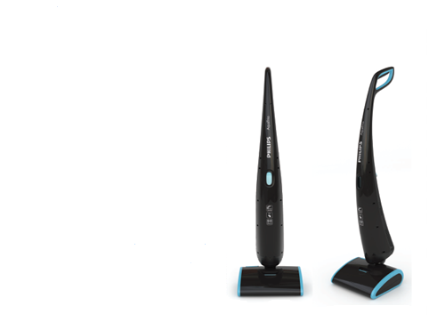

Product introduction
With the introduction of AquaTrio Philips takes a leading position in the wet cleaning segment, but only in the very high-end segment. Current AquaTrio consumer and customer feedback is clear: AquaTrio is very much appreciated but the price point is set high (RRP 449 Euro, 4999 RMB) and prevents (more) consumers from purchasing.
It is crucial to offer AquaTrio (Poseidon) at a more accessible price point to generate higher sales and stronger market penetration, utilizing the investments made in AquaTrio (Ocenanos).
This product range will be positioned as RSP € 349,99.

VPH

Consumer care focus:
For this product we carry out the standard consumer care package +
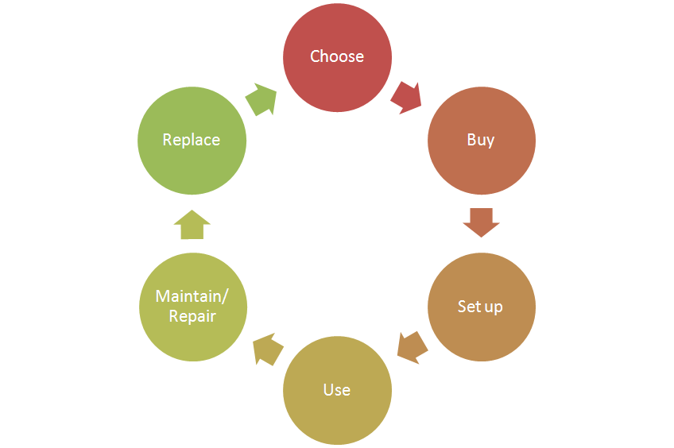
- Choose:
Support the “ Cleans the floor in one go “-theme
by clear communication of the key benefits (vacuuming, mopping, drying
In one go)
- Buy:
- Setup:
  - Supporting the accessories included (list available accessories
and where to buy to enable consumer to upgrade)
- Use:
a) Clear communication on suitable types of floors
- Maintain/repair:
a) Product experience enhancement especially why, how to clean the
brushes,
- Replace:

CRM strategy:
Integration CRM (compelling reason for registration, in box communication, follow up upon registration)

Sales introduction and IPD milestone planning
 | Month of introduction | Planned sales year of introduction (x k) | Planned sales total 2013-2016 (x k)
France | 2013 | 2 | 4
Italy | 2013 | 1 | 3
Greater China | 2013 | 2 | 77
Turkey | 2013 | 1 | 10
Russia | 2013 | 3 | 8
ISO CEE | 2013 | 1 | 9
Poland | 2013 | 1 | 4
Nordics | 2013 | 1 | 5
Benelux | 2013 | 1 | 16
DACH | 2013 | 2 | 24
Rest of Asea | 2013 | 5 | 55


IR
AA
PPC
PV
CR
PE
VPD
IR
PC
Project Plan Committed PPC: 1248
Industrial Release IR: 1328
Commercial Release CR: 1331

Warranty and service policy

- 2 Year warranty
- Replacement, Carry in, repair by component swap.

Accessories & Consumer Replaceable Parts

Accessories | Commercial CTN |  | Online shop / consumer price
Brush heads (set of 2) | FC 8054 |  | € 27,99
Spare part | Consumer Replaceable Part | Commercial Accessory | Online shop price
Clean water tank | Y | N | €23,99
Lid assy dirty water tank | Y | N | €39,49
Dirty water tank | Y | N | €22,99
Brush cover | Y | N | €24,49
Driptray | Y | N | €52,99

Consumer touch points for consumer care

ROW | - In-box  - Web (.com / .care)  - Call Center  - Service Centers  - Trade

CoNQ prediction & cost driver assumption

CoNQ as % of sales: 2,43 %
FCR: 7, 8%
CPI: € 32,14 average
Call center cost as % of sales: 20 %

Consumer care package
Item | Detail | Availability timing | Owner | Cost (T.I.C) / Marcom budget
In-box
 | User Manual | PV (text)  IR (final) | Charel v. Nassau
 | Quick Start Guide | IR | Marijse Bulthuis
 | World Wide Guarantee Card | IR | Marijse Bulthuis
 | Inbox leaflet | IR | Marijse Bulthuis
 | Worldwide guarantee leaflet | IR | Marijse Bulthuis
Web
 | Leaflet and Photo's | CR | Sonaiska Barbera Cote
 | Specifications in leaflet covered (size, dimensions, weight etc.) (PFS) | CR | Sonaiska Barbera Cote
 | Support movies | CR | Niels Goedvolk | €
 | Pre-purchase FAQ's | CR | Niels Goedvolk
 | Post-purchase FAQ's | CR | Niels Goedvolk
 | Tips & Tricks | CR | n.a.
 | Consumer Care Leaflet | CR | CEM
 | CRP Online sales (deliver  WOW / Marketing Txt) | CR | Yvonne Dingsté / Sonaiska Barbera Cote
 | Web reviews | CR | n.a. | €
Call Center
 | Training package - technical and soft skills | IR | Niels Goedvolk  Charel v. Nassau Sonaiska Barbera Cote  Yvonne Dingsté
 | Training execution (Powerpoint/online) | CR | Niels Goedvolk | €
 | Commercial Product samples | IR | Hans Kuperus | €
 | Call center Feedback | CR | n.a. ? | €
Service Centers
 | Service Manual | CR - 2WK | Yvonne Dingsté | €
 | Service Bill of Material, incl. spare parts Purchasing Master data | CR - 2WK | Yvonne Dingsté
 | Training package diagnostics & repair | CR | Yvonne Dingsté

Consumer experience feedback loop
There will be limited monitoring on the Consumer Feedback (Call centers).

