Consumer Care Book MSI Robot
FC8800/FC8802

Approved by:

CMM: Daniel Abbo

(Sign off via PPIM)

Author: | Gérard Verkerk/Yvonne Dingste
Date: | 13-04-2012
AKB: | AKB 32GV-120023 Consumer Care Book Harrier Europe FC
Version: | PPC

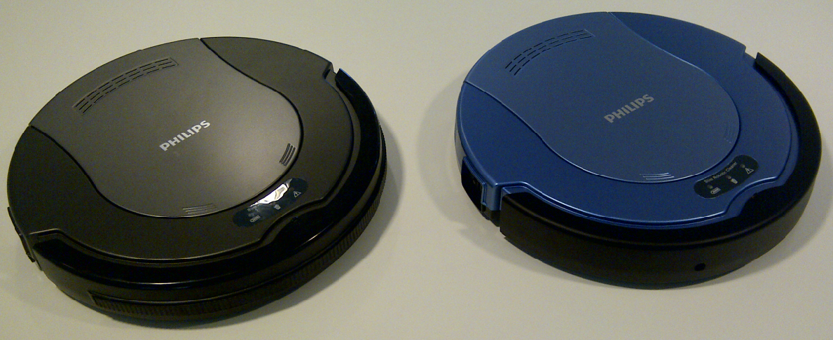

Product introduction

The Harrier project will enable Philips to enter the competitive low end RVC market in Europe with an entry-price proposition to capture those customers coming new into the category. RVC’s offer a unique opportunity to bring people into the market that doesn’t see traditional VC’s as the solution to their needs and do see RVC’s as meaningful innovation to improve their quality of live. Going price of the robot (FC8800) €179 - 199, two color SKU’s available.

VPH
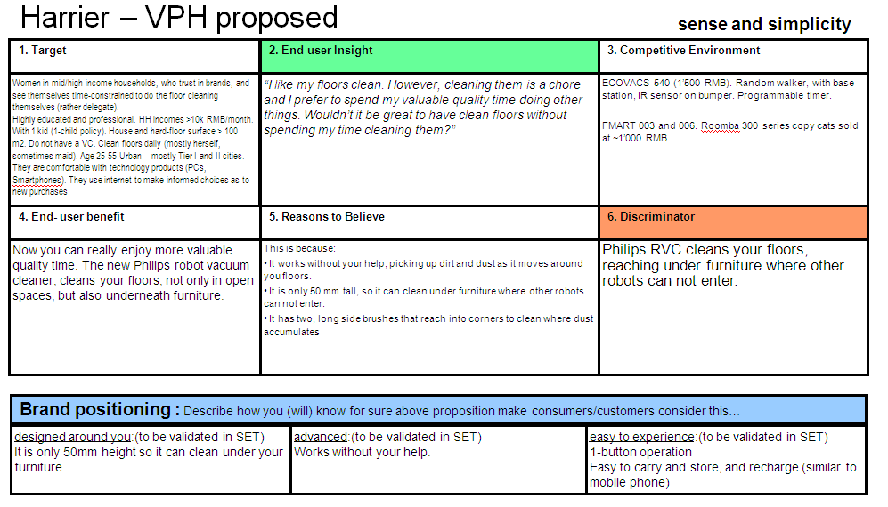

CRM strategy:

Integration CRM (compelling reason for registration, in box communication, follow up upon registration) t.b.d.

Consumer care focus:
Consumer Education
- Choose:
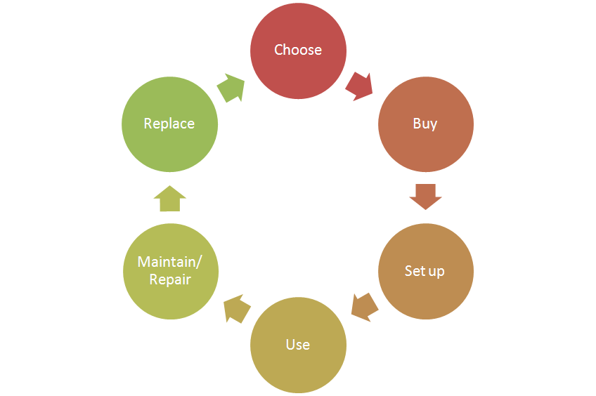
  - Reconfirm the believability of the proposition by explain the wow/unique
features of the product:
    - Slim design, only 60mm high also enables cleaning under furniture.
    - The 2 long side brushes also reach difficult spots in the corners.
    - Simplicity, only one button operation, no programming needed.
- Buy:
  - Explain benefits on robot vacuum cleaning, why is it good for you.
- Setup:
  - Demonstrate how the product works.
- Use:
  - Support the “Ease of use” theme by clear communication of the
key benefits how to get most out of the product.
- Maintain/repair:
  - Cleaning and maintenance education. (charging behavior / daily cleaning)
- Replace:
  - Ensure CRP’s (especially battery, filter and side brushes) are easy obtainable for consumers.

Sales introduction and IPD milestone planning
Country | Month of introduction | Planned sales year of introduction (x k) | Planned sales total 2012-2014 (x k)
France | Sep-2012 | 3 | 17
DACH | Sep-2012 | 1 | 5
Iberia | Sep-2012 | 1 | 5
Benelux | Sep-2012 | 1 | 5
Nordic | Sep-2012 | 1 | 3
CEE | Sep-2012 | 6 | 28
Total |  | 13 | 63


IR
AA
PPC
PV
CR
PE
VPD
IR
PC
Project Plan Committed PPC: 1216
Industrial Release IR: 1225
Commercial Release CR: 1225

Warranty and service policy.

- 2 Year warranty. (battery excluded 6Months warranty)
- Carry in repair.

Accessories & Consumer Replaceable Parts

Spare part | Shop price (€)
Filter (4222 459 54021) | 4.99
Side brushes (set of two) (4222 459 54031) | 9.99
Rechargeable battery (4222 459 54041) | 29,99
Dust container (4222 459 54051) | 9.99

Consumer touch points for consumer care

China | - In-box  - Web (.com / .care)  - Call Center  - Repair center  - Retail

CoNQ prediction & cost driver assumption

CoNQ as % of sales: 4,77%
FCR: 14,78%
CPI: € 23,82
Call center cost as % of sales: 8,5%

Consumer care package
Item | Detail | Availability timing | Owner | Cost (T.I.C) / Marcom budget
In-box
 | User Manual | PV (text)  IR (final) | Willemijn Westendorp
 | Quick Start Guide | IR | Willemijn Westendorp
 | Guarantee Card | IR | Judy Danoe
Web
 | Leaflet and Photo's | CR | Daniel Abbo
 | Technical info on leaflet (size, dimensions, weight etc.) | CR | Daniel Abbo
 | Pre-purchase FAQ's | CR | Niels Goedvolk Willemijn Westendorp Daniel Abbo
 | Post-purchase FAQ's | CR | Niels Goedvolk  Willemijn Westendorp
 | Tips & Tricks | CR | Niels Goedvolk  Willemijn Westendorp
 | Support Movies (usage, cleaning/maintenance appliance) | CR | Niels Goedvolk
 | Web reviews |  | Niels Goedvolk | Philips Bazaar tool only
Call Center
 | Training package - technical and soft skills | IR | Niels Goedvolk Willemijn Westendorp  Daniel Abbo
 | Training execution (online) | CR | Niels Goedvolk | Call center
 | Commercial Product samples for Call center | IR | Daniel Abbo  Pieter Trinks | €600,- 8 appliances total)
 | Call center Feedback | CR | Niels Goedvolk | 80 - 100hours
Service Centers
 | Service Manual | CR - 2WK | Yvonne Dingsté
 | Service Bill of Material, incl. spare parts Purchasing Master data | CR - 2WK | Yvonne Dingsté
 | Repair Training package | CR – 2WK | Yvonne Dingsté

Consumer experience feedback loop
Call center will be planned by CO consumer care.

Any relevant specifics for execution

Brief SO about battery warranty limitation set to 6Months. (Explain why + get it executed)
Ensure battery and parts are easy (online?) obtainable for consumers.

