Consumer Care Book Olympus (DailyDuo Facelift) appliance FC6161/xx

Approved by:

CMM:, Barber Cote, Sonaiska
PPIM sign off

Date: 2012/03

Author: | Gérard Verkerk/Yvonne Dingsté
Date: | 09-03-2012
AKB: | AKB 32GV-120016 Consumer Care Book Olympus FC
Version: | Final

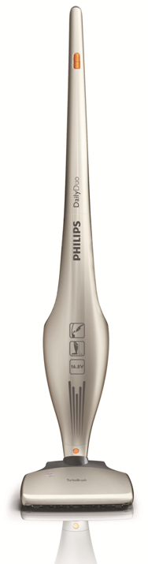

Product introduction

With this project we will replace the existing DailyDuo range. By upgrading our product design, we are aiming to have a stronger and powerful product proposition on the shelf to pull consumers to purchase the appliance. This product will be positioned between EUR 110-159.

VPH
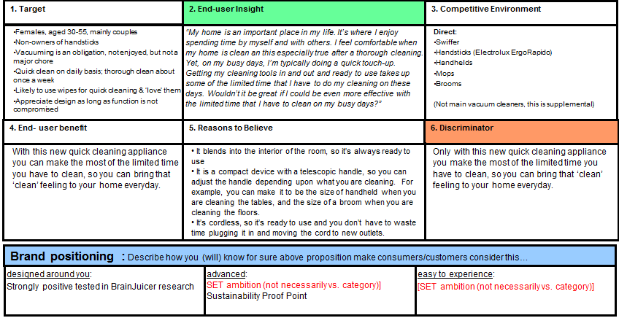

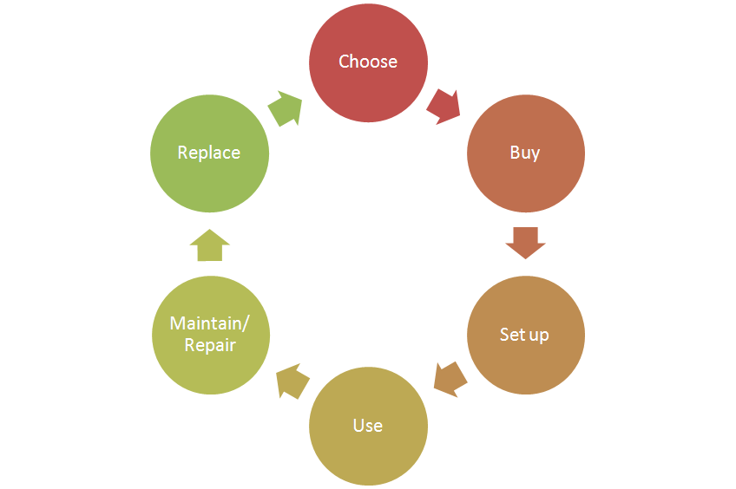
Consumer care focus

For this product we carry out the standard consumer care package.
- Choose:
- Buy:
- Setup:
- Use:
- Maintain/repair:
  - Product experience enhancement especially why, how to clean the filters,
where they are located and how to purchase.
- Replace:

CRM strategy:

Integration CRM (compelling reason for registration, in box communication, follow up upon registration) t.b.d.

Sales introduction and IPD milestone planning

Country | Month of preliminary  introduction | Month of mass  introduction | Planned sales total period 2012-2018 (x k)
W-Europe | Sep 2012 | 18 | 45
CEE-Poland | Sep 2012 | 3 | 8
Russia | Sep 2012 | 3 | 8
Japan | Sep 2012 | 5 | 30
China | Sep 2012 | 23 | 52
Korea | Sep 2012 | 7 | 18
Turkey | Sep 2012 | 2 | 6


IR
AA
PPC
PV
CR
PE
VPD
IR
PC
Project Plan Committed PPC: 1212
Industrial Release IR: 1221
Commercial Release CR: 1223

Warranty and service policy

- 2 Year warranty.
- WEU replacement policy, ROW Carry in, repair by component swap.

Accessories & Consumer Replaceable Parts

Accessories | Commercial CTN | Online shop / consumer price
n.a.
CRP | Consumer Replaceable Part (CRP) | Online shop price
HEPA filter | Y | €9,99
Mesh filter | Y | €5,99

Consumer touch points for consumer care

ROW | - In-box  - Web (.com / .care)  - Call Center  - Trade  - Service Centers

CoNQ prediction & cost driver assumption

CoNQ as % of sales: 1,52%
FCR:4,27%
CPI: €23,31
Call center contact rate as % of sales: 2%

Consumer care package
Item | Detail | Availability timing | Owner | Cost (T.I.C) / Marcom budget
In-box
 | User Manual | PV (text)  IR (final) | Marijse Bulthuis
 | Quick Start Guide | IR | Only China
 | CRM card | IR | n.a./?
 | World Wide Guarantee Card | IR | Judy Danoe
Web
 | Leaflet and Photo's | CR | Sonaiska Barber Cote
 | Technical info on leaflet (size, dimensions, weight etc.) | CR | Sonaiska Barber Cote
 | Pre-purchase FAQ's | CR | Sonaiska Barber Cote /Kathy Lau /Niels Goedvolk
 | Post-purchase FAQ's | CR | Kathy Lau/Niels Goedvolk
 | Consumer Care Leaflet | CR | CEM
 | CRP Online sales (deliver WOW/Marketing text) | CR | Sonaiska Barber Cote / Yvonne Dingsté
 | Movies | CR | 1 Movie is planned.
 | Web reviews | CR-PE | n.a.
Call Center
 | Training package creation - technical and soft skills. | IR | Niels Goedvolk  Sonaiska Barber | Portfolio update only
 | Training execution (online) | CR | n.a. | Provide PPT
 | Commercial Product samples | IR | Sam Chan | €600,- (12 appliances total)
Service Centers
 | Service Manual | CR - 2WK | Yvonne Dingsté
 | Service Bill of Material, incl. spare parts Purchasing Master data | CR - 2WK | Yvonne Dingsté
 | Training package diagnostics & repair | CR | n.a.

Consumer experience feedback loop
Consumer experience feedback, one report will be issued 3Months after launch.

