Consumer Care Book Gulo Bag appliance FCxxxx

Approved by:

CMM: Suzanne van de Sandt,
(Please place a signature)

Date: 2012/01

Author: | Gérard Verkerk/Yvonne Dingsté
Date: | 11-01-2012
AKB: | AKB 32GV-1100050 Consumer Care Book Gulo Bag appliance FC
Version: | Final



Product introduction

With this project we will deliver significant and profitable growth by focusing on core, key markets and promising “superior cleaning performance in bag”.
This project will offer consumers “A Better Clean” through Powerful Performance, enabled by: superior technology (nozzle, and high constant suction power, even with a full bag).
The new range aims to replace Jewel, StudioPower and on the longer term phased out of Performer. This product range will be positioned between EUR 129-189.

VPH
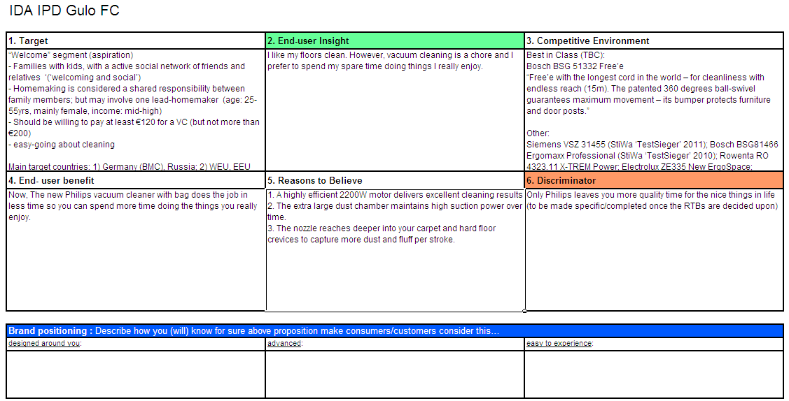

Consumer care focus
For this product we carry out the standard consumer care package +
- Choose:
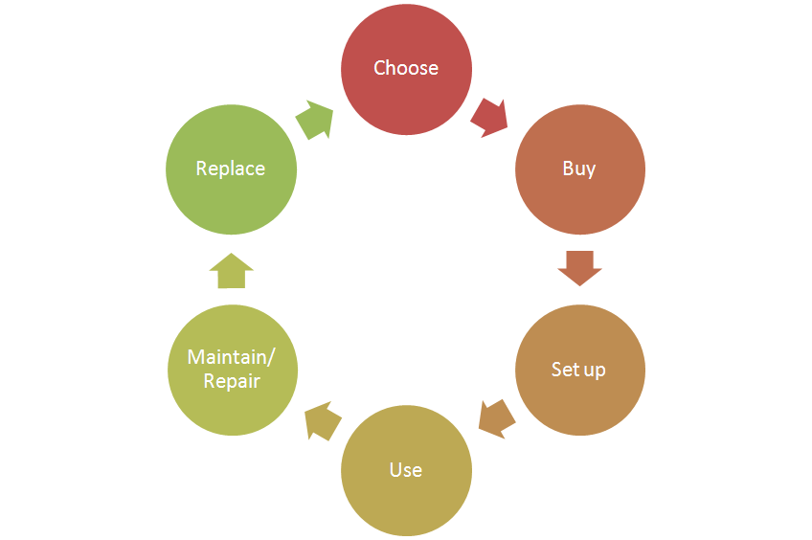
  - Support the “superior cleaning performance” theme by clear communication of
the key benefits. (Perfect dust pickup & long lasting suction performance
also with a full bag due to the special designed dust compartment.
- Buy:
- Setup:
  - Supporting the new accessories (list available accessories and where
to buy to enable consumer to upgrade)
- Use:
  - Support the “superior cleaning performance” theme by clear
communication of the key benefits. (tip: Ultra long dust bag)
- Maintain/repair:
  - Product experience enhancement especially why, how to clean the filters,
where they are located and how to purchase.
  - Video’s to show how to clean the filters.
- Replace:

CRM strategy:

Integration CRM (compelling reason for registration, in box communication, follow up upon registration) t.b.d. (5 year motor warranty?)

Sales introduction and IPD milestone planning

Country | Month of preliminary  introduction | Month of mass  introduction | Planned sales year 2012 / 2013 (x k) | Planned sales total period 2012-2018 (x k)
DACH | Nov 2012 | March 2013 | 32 | 203
France |  | March 2013 | 9 | 56
Benelux | Nov 2012 | March 2013 | 26 | 169
Nordic |  | March 2013 | 10 | 62
Russia | Nov 2012 | March 2013 | 39 | 253
CEE |  | March 2013 | 22 | 141
Ukraine |  | March 2013 | 7 | 45
Poland |  | March 2013 | 10 | 62
Turkey | Nov 2012 | March 2013 | 7 | 45
MEA |  | March 2013 | 14 | 90
Total |  |  | 175 | 1125
*Launch window/qyt’s are draft still.


IR
AA
PPC
PV
CR
PE
VPD
IR
PC
Project Plan Committed PPC: 1202
Industrial Release IR: 1235
Commercial Release CR: 1241

Warranty and service policy

- 2 Year warranty.
- Carry in, repair by component swap.

Accessories & Consumer Replaceable Parts

Accessories | Commercial CTN | Online shop / consumer price
Super parquet nozzle | FC 8042/01 | € 34,99
*TriActive Nozzle | FC 8052/01 | € 35,99
Turbo Brush Nozzle | FC8043/01 | €49,99
Hard Floor Nozzle | FC8049/01 | €17,49
Standard Nozzle RD264 | FC8050/01 | € 18,50
HEPA 13 (washable) | FC8038/01 | € 19,99
HEPA 12 (washable) | FC8044/02 | € 22,49
AFS Microfilter | FC8030/01 | € 3,49
CRP | Consumer Replaceable Part (CRP) | Online shop price
*2 pcs. metal Telescopic tube | Y | € 19,99
*Crevice nozzle | Y | € 3,99
*Small nozzle | Y | € 9,99
*Tubeclip | Y | € 2,99
*accessories will be newly developed

Consumer touch points for consumer care

ROW | - In-box  - Web (.com / .care)  - Call Center  - Trade  - Service Centers

CoNQ prediction & cost driver assumption

CoNQ as % of sales: 1,71 %
FCR:4.36 %
CPI: € 29,40
Call center cost as % of sales: 1.10 %

Consumer care package
Item | Detail | Availability timing | Owner | Cost (T.I.C) / Marcom budget
In-box
 | User Manual | PV (text)  IR (final) | Suzanne van de Sandt
 | Quick Start Guide | IR | n.a.
 | CRM card | IR | Suzanne van de Sandt/t.b.d.
 | World Wide Guarantee Card | IR | Judy Danoe
Web
 | Leaflet and Photo's | CR | Suzanne van de Sandt
 | Technical info on leaflet (size, dimensions, weight etc.) | CR | Suzanne van de Sandt
 | Pre-purchase FAQ's | CR | Suzanne van de Sandt /Bas Berga /Fenna Lesman
 | Post-purchase FAQ's | CR | Bas Berga/Fenna Lesman
 | Consumer Care Leaflet | CR | CEM
 | CRP Online sales (deliver WOW/Marketing text) | CR | Suzanne van de Sandt / Yvonne Dingsté
 | Movies | CR | Fenna Lesman
 | Web reviews | CR-PE | n.a.
Call Center
 | Training package creation - technical and soft skills. | IR | Bas Berga/Fenna LesmanSuzanne van de Sandt/Yvonne Dingsté
 | Training execution (online) | CR | Fenna Lesman
 | Commercial Product samples | IR | Erik Smit | €600,- (12 appliances total)
Service Centers
 | Service Manual | CR - 2WK | Yvonne Dingsté
 | Service Bill of Material, incl. spare parts Purchasing Master data | CR - 2WK | Yvonne Dingsté
 | Training package diagnostics & repair | CR | Yvonne Dingsté

Consumer experience feedback loop
Consumer experience feedback:
Monitoring Call center calls + Reviews on the Philips website.

