
Consumer Lifestyle

Consumer Care Book
HAWAII

FC616x, FC617x, FC618x
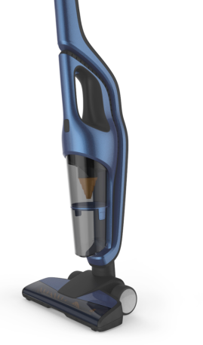
Approval
Consumer Marketing Manager

To be approved via PPIM

Author: | Yvonne Dingste, Niels Goedvolk
Date: | June 7, 2013
AKB: | AKB 229F-130808
Category: | DA-Floorcare
Status: | Final
Version: | PPC
AKB-number generator

Product introduction
- Hawaii is the new design-technology platform that will bring the new positioning of a Better Clean alive into the Quick Cleaning segment.
- Handstick cordless market ~308M€, growing in average by 15%.
- Strong market leaders are Electrolux (41% MS) and Rowenta (25% MS)
- Philips FC is not competitive enough and lacks of a full handstick range. Current products are based on old positioning.
- The aim is to launch a 2-in-1 stick (Q1 2014) and only stick product range (Q3 2014), given handhelds if possible (tbd)
- Hawaii platform will have commonality of tooling set and end-user benefit.
- Main claim direction is “Best performance on all floors”, supported with New nozzle and Power Cyclone technology.

VPH
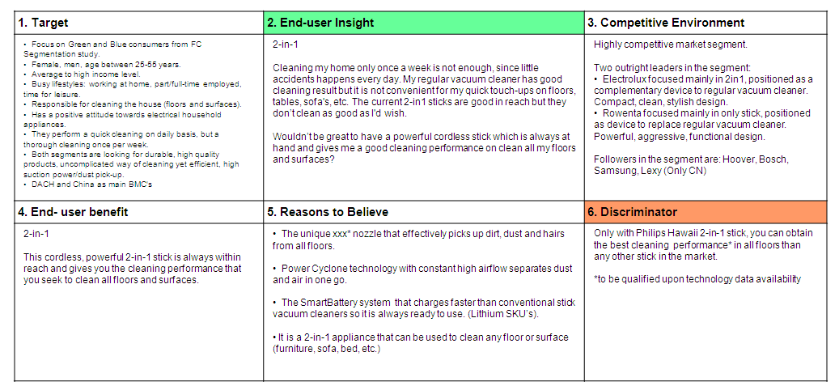

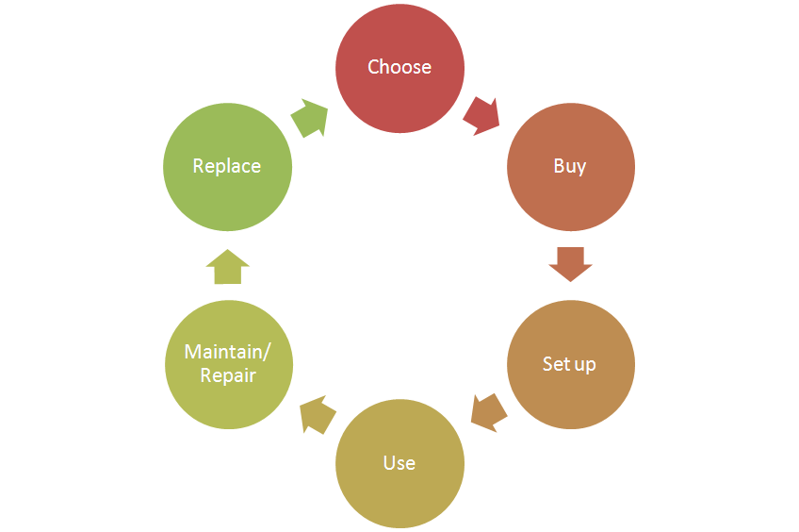
Consumer care focus:
For this product we carry out the standard consumer care package +
- Choose: Inform consumer on 2+1 function, specifications and ease of use
- Buy: Inform consumer where to buy via web and call centers
- Setup: How to prepare for first time use
- Use: Tips & Tricks for surfaces and all floor use
- Maintain/repair: Troubleshoot and maintenance FAQs, tips tricks how to clean filter and how to empty dust bucket.
- Replace: depending on CC strategy

CRM strategy:
Aim is to add CRM card to High End Models.

Sales introduction and IPD milestone planning
FC616x & FC618x – 2in1 appliance
Business Market Combination (BMC) | Launchdate (LD) | Planned sales intro year /BMC  (x1000) | Total planned sales /BMC  (x1000)
China | WK1412 | 28 | 275
DACH | WK1412 | 35 | 164

FC616x & FC618x – Stick only
Business Market Combination (BMC) | Launchdate (LD) | Planned sales intro year /BMC  (x1000) | Total planned sales /BMC  (x1000)
China | Wk1437
DACH | WK1437


IR
AA
PPC
PV
CR
PE
VPD
IR
PC
Project Plan Committed PPC: WK1324
Prototype Consolidation PC: WK1328
Product Validated PV: WK1343
Industrial Release IR: WK1347
Commercial Release CR: WK1412

Warranty and service policy

- 2 Year warranty
- Mainly replacement, accessories repair by component swap.

Proposed Accessories & Consumer Replaceable Parts

Accessories: | Online shop price
Small Crevice
Small Nozzle

Consumer Replaceable Parts | Online shop price
Filter
Dust Bucket
Charging base
Handheld?

CoNQ prediction & cost driver assumption

CoNQ as % of sales: 1,72%
CREX Best estimate: 4.1%
CPI: € 21,68
Call center cost as % of sales: 1,57%

Consumer care package
Item | Detail | Availability timing | Owner | Cost (T.I.C) / Marcom budget
Front-end Touchpoints
In-box
 | User Manual | PV (text)  IR (final) | Erik Smit
 | Quick Start Guide | IR | N/A
 | Inbox leaflet | IR | Sonaiska Barber
 | Worldwide guarantee leaflet | IR | Sonaiska Barber
Web
 | Leaflet and Photo's | CR | Sonaiska Barber
 | Specifications in leaflet covered (size, dimensions, weight etc.) (PFS) | CR | Sonaiska Barber
 | Accessory information linked to CTN’s / online (PFS) | CR | Sonaiska Barber
 | Support movies | CR | Sonaiska Barber | €
 | Pre-purchase FAQ's | CR | Niels Goedvolk
 | Post-purchase FAQ's | CR | Niels Goedvolk
 | Tips & Tricks | CR | Niels Goedvolk
 | Consumer Care Leaflet | CR | CEM
 | Web reviews | CR | Niels Goedvolk or Infotech (tbd) | € tbd
Call Center
 | Training package - technical and soft skills | IR | Niels Goedvolk & Sonaiske Barber
 | Training execution (Powerpoint/online/onsite) | CR | Niels Goedvolk | €
 | Commercial Product samples | IR | Sonaiske Barber | €
 | Call center Feedback | CR | Niels Goedvolk | €
Back-end Touchpoints
Service Centers
 | Service Manual | CR | Yvonne Dingste
 | Service Bill of Material, incl. spare parts Purchasing Master data | CR - 2WK | Yvonne Dingste
 | Training package diagnostics & repair | CR | Yvonne Dingste

Consumer experience feedback loop
5 month after CR date bi weekly feedback loop by Knowledge Engineer N. Goedvolk, Webreviews analyzed by Infotech (tbd).

