Consumer Care Book Buffalo Bagless appliance FCxxxx

Approved by:

CMM: Aymen Mnif,
(Sign off via PPIM)

Author: | Gérard Verkerk/Yvonne Dingsté
Date: | 07-06-2012
AKB: | AKB 32GV-120033 Consumer Care Book Buffalo Bagless FC
Version: | Final

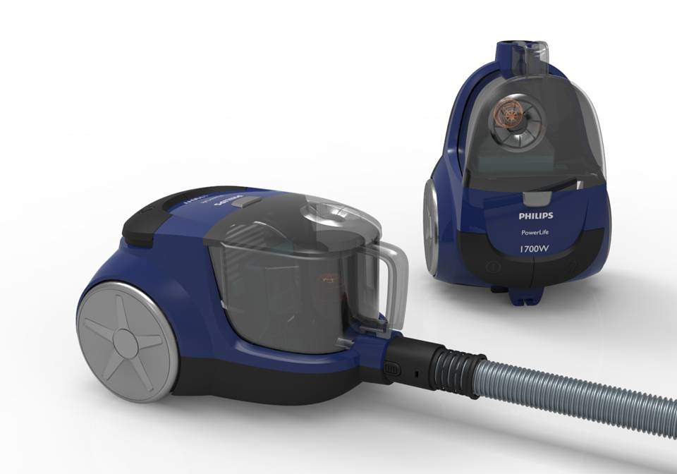

Product introduction

Philips Floorcare is strategically positioning itself in the core of the Bag and Bageless (80% of the market) 50% of the Bagless market are appliance below the 100Euro price point. With this project we will deliver profitable organic growth by entering the lower price point. Deliver a strong and diversified Bagless portfolio to become a strong generalist player in our key markets. This product range will be positioned between 75-100Euro.

VPH
For this project the generic Floorcare VPH is valid :
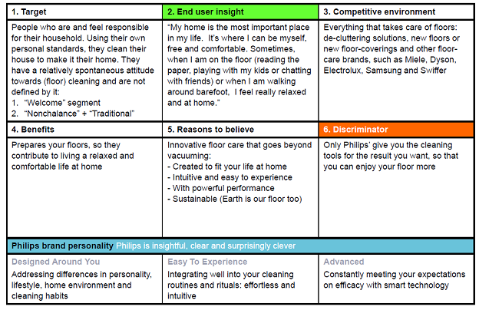

Consumer care focus
For this product we carry out the standard consumer care package +
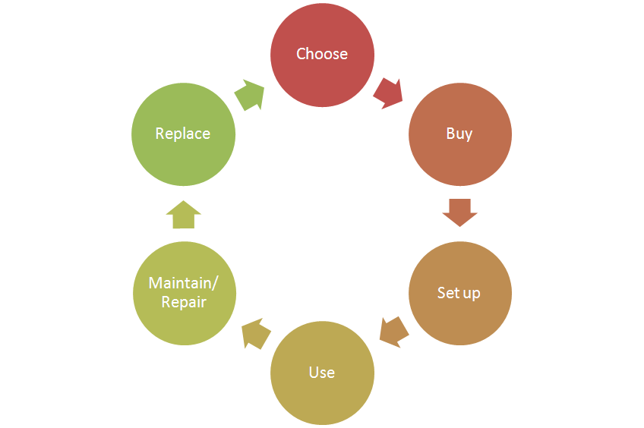
- Choose:
  - Support the “Higher suction power, with better cleaning results” theme
by clear communication of the key benefits.(latest cyclone technology)
- Buy:
- Setup:
  - Supporting the accessories included (list available accessories and
where to buy to enable consumer to upgrade)
- Use:
- Maintain/repair:
  - Product experience enhancement especially why, how to clean the filters,
where they are located and how to purchase.
- Replace:

CRM strategy:

Integration CRM (compelling reason for registration, in box communication, follow up upon registration) t.b.d. (5 year motor warranty?)

Sales introduction and IPD milestone planning

Country | Month of preliminary  introduction | First year production | Total planned sales year 2013 / 2016 (x k)
Russia | March 2013 | 36 | 246
CEE | March 2013 | 8 | 37
DACH | March 2013 | 20 | 92
Benelux | March 2013 | 50 | 230
Ukraine | March 2013 | 5 | 23
France | March 2013 | 10 | 46
Turkey | March 2013 | 20 | 92
Nordic | March 2013 | 10 | 46
Poland | March 2013 | 10 | 46
MEA | March 2013 | 13 | 60
Iberia | March 2013 | 4 | 18
Total |  | 186 | 934


IR
AA
PPC
PV
CR
PE
VPD
IR
PC
Project Plan Committed PPC: 1225
Industrial Release IR: 1249
Commercial Release CR: 1252

Warranty and service policy

- 2 Year warranty.
- Carry in, repair by component swap.

Accessories & Consumer Replaceable Parts

Accessories | Commercial CTN | Online shop / consumer price
Hard Floor Nozzle (Powerlife) | FC8049/01 | €17,49
All purpose nozzle (std) | FC8050 | € 18,50
CRP | Consumer Replaceable Part (CRP) | Online shop price
All purpose nozzle with fluff pick up | N | n.a.
HEPA 13 (new) | Y | € 19,99
AFS Microfilter (new) | Y | € 3,49
Turbo brush Nozzle (new) | N | € 24,99
HF Nozzle (CRP 749) | Y | € 24,99
2 pcs. metal Telescopic tube (new) | Y | € 31,99
2 pcs. metal tube (new) | Y | € 31,99
Crevice nozzle (Powerlife) | Y | € 3,99
Small nozzle (Powerlife) | Y | € 9,99
Tubeclip (Powerlife) | Y | € 2,99
*accessories will be newly developed

Consumer touch points for consumer care

ROW | - In-box  - Web (.com / .care)  - Call Center  - Trade  - Service Centers

CoNQ prediction & cost driver assumption

CoNQ as % of sales: 2,27 %
FCR:3.65%
CPI: €26,40
Call center cost as % of sales: 0,3%

Consumer care package
Item | Detail | Availability timing | Owner | Cost (T.I.C) / Marcom budget
In-box
 | User Manual | PV (text)  IR (final) | Bert van Kalkar
 | Quick Start Guide | IR | n.a.
 | CRM card | IR | t.b.d.
 | World Wide Guarantee Card | IR | Marijse Bulthuis
Web
 | Leaflet and Photo's | CR | Aymen Mnif
 | Technical info on leaflet (size, dimensions, weight etc.) | CR | Aymen Mnif
 | Pre-purchase FAQ's | CR | Niels Goedvolk Aymen Mnif  Bert van Kalkar
 | Post-purchase FAQ's | CR | Niels Goedvolk  Bert van Kalkar
 | Consumer Care Leaflet | CR | CEM
 | CRP Online sales (deliver WOW/Marketing text) | CR | Yvonne Dingsté Aymen Mnif
 | Movies | CR | n.a.
 | Web reviews | CR-PE | n.a.
Call Center
 | Training package creation - technical and soft skills. | IR | Niels Goedvolk  Bert van Kalkar Aymen Mnif  Yvonne Dingsté
 | Training execution (online) | CR | Niels Goedvolk
 | Commercial Product samples | IR | Kai Wai Chan | €700,- (14 appliances total)
Service Centers
 | Service Manual | CR - 2WK | Yvonne Dingsté
 | Service Bill of Material, incl. spare parts Purchasing Master data | CR - 2WK | Yvonne Dingsté
 | Training package diagnostics & repair | CR | Yvonne Dingsté

Consumer experience feedback loop
There will be no monitoring of consumer experience feedback. (only ad hoc)

