Consumer Care Book Octopus FCxxxx

Approved by:

CMM:, Angelika Dietrich-Winkler
PPIM sign off

Author: | Gérard Verkerk/Yvonne Dingsté
Date: | 11-05-2012
AKB: | AKB 32GV-120027 Consumer Care Book Octopus steamer FC
Version: | Final

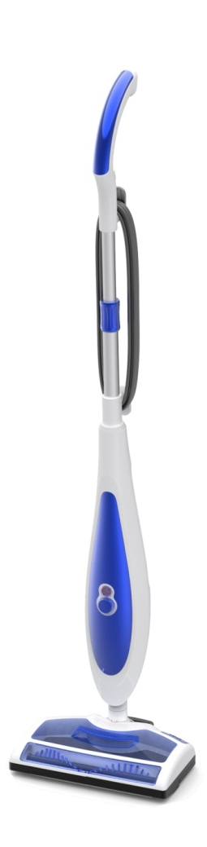

Product introduction

With the introduction of AquaTrio Philips will claim a position in the wet cleaning segment, but this will be only in the very high-end segment (EUR 449). We will need lower-end proposition to support the AquaTrio, and expand our presence in the wet cleaning segment. With this project we will be able to introduce a wet steam & mopping system on a much lower price point (100 - 110Euro). Especial for China the current price proposition will cover the lower end of the wet cleaning market. This product will be positioned around 999RMB.

VPH
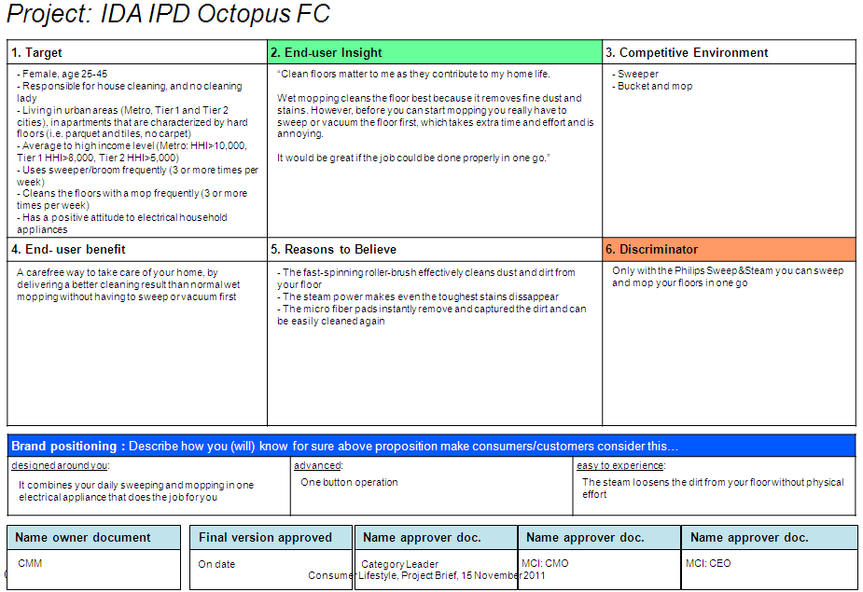

CRM strategy:

N.a.

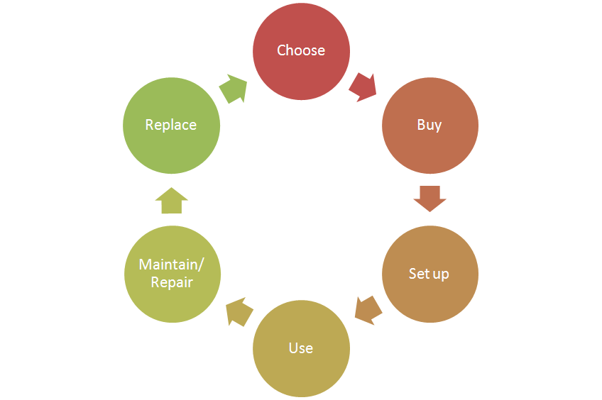
Consumer care focus

For this product we carry out the standard consumer care package.
- Choose:
  - Explain the wow/unique features of the product.
Steam is able to dissolve stains and to kill many types of germs.
  - Demonstrate how the product works.
- Buy:
- Setup:
  - Use: Support the “Ease of use” theme by clear communication of the
key benefits. (tips in easy to empty dust container?)
- Maintain/repair:
  - Product experience enhancement especially why, how to clean the filters,
where they are located and how to purchase.
- Replace:

Sales introduction and IPD milestone planning

Country | Month of introduction | Planned sales year of introduction (x k) | Planned sales total 2012-2016 (x k)
China(incl. HK) | Jan 2013 | 17 | 232


IR
AA
PPC
PV
CR
PE
VPD
IR
PC
Project Plan Committed PPC: 1221
Industrial Release IR: 1244
Commercial Release CR: 1246

Warranty and service policy

- 2 Year warranty.
- Repair policy. (Carry in, component swap).

Accessories & Consumer Replaceable Parts

Accessories | Commercial CTN | ASC/ASD | Online shop / consumer price
2 cleaning microfiber pads | FCxxxx | Y | X
Filter (de calc) |  | Y | X
 |  | Y
CRP | Consumer Replaceable Part (CRP) |  | Online shop price
Filter?/citric acid? | Y | Y | X
Water tank | Y | Y | X
Telescopic metal tube | y | Y | X
Dust chamber? | Y | Y | X
Brush.

Consumer touch points for consumer care

ROW | - In-box  - Web (.com / .care)  - Call Center  - Trade  - Service Centers

CoNQ prediction & cost driver assumption

CoNQ as % of sales: 0,65%
FCR:3,26%
CPI: €10,99
Call center contact rate as % of sales: 2%

Consumer care package
Item | Detail | Availability timing | Owner | Cost (T.I.C) / Marcom budget
In-box
 | User Manual | PV (text)  IR (final) | Marijse Bulthuis
 | Quick Start Guide | IR | n.a.
 | CRM card | IR | n.a.
 | World Wide Guarantee Card | IR | Judy Danoe
Web
 | Leaflet and Photo's | CR | Angelika Dietrich-Winkler
 | Technical info on leaflet (size, dimensions, weight etc.) | CR | Angelika Dietrich-Winkler
 | Pre-purchase FAQ's | CR | Niels Goedvolk Angelika Dietrich-Winkler  Richard Jousma /
 | Post-purchase FAQ's | CR | Niels Goedvolk Richard Jousma/  ?HK colleague
 | Consumer Care Leaflet | CR | CEM
 | CRP Online sales (deliver WOW/Marketing text) | CR | n.a.
 | Movies | CR | n.a. | Marcom budget
 | Web reviews | CR-PE | n.a.
Call Center
 | Training package creation - technical and soft skills. | IR | Niels Goedvolk  Angelika Dietrich-Winkler | Portfolio update only
 | Training execution (online) | CR | Niels Goedvolk
 | Commercial Product samples | IR | Marcel Schroor | €150,- (2 appliances total)
Service Centers
 | Service Manual | CR - 2WK | Yvonne Dingsté
 | Service Bill of Material, incl. spare parts Purchasing Master data | CR - 2WK | Yvonne Dingsté
 | Training package diagnostics & repair | CR | n.a.

Consumer experience feedback loop
There is no consumer experience feedback planned.

