Consumer Care Book
Bull

Type numbers
_{September 2010 Launch}
FC8140, FC8142 Bagless
FC8130, FC8132, FC8134, FC8136 Bag
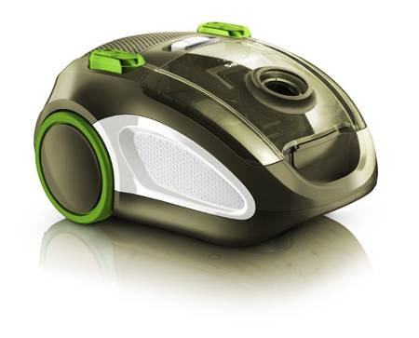

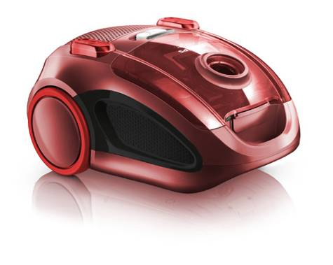
Category: Floorcare
CMM: Elise Michel-Paulsen

(Please place a scan signature)

Date: YEAR/MM/DD
Author: Willem Brouwer
Date: 2010/05/25
Version: Final V1.1
AKB nummer: AKB 32WB-0900055
No. of pages: 12
Index

1 Introduction, planning 3
1.1 General Introduction 3
1.2 IPD milestones 3
1.3 Introduction Regions/countries, Quantities, Price 3
1.4 Consumer Service Offering (CSO) and repair process 4
2 Technical specifications 5
2.1 Range overview 5
2.2 Product specifications 6
2.3 New commercial features 7
2.4 Commercial Accessories 7
3 Architecture and characteristics 7
3.1 Mechanical 7
3.2 Electrical 7
3.3 Critical spare parts 8
3.4 Consumer replaceable parts 8
4 Cost of non quality prediction 8
4.1 Call center cost 8
4.2 CPI (Cost per Intervention) 9
4.3 Predicted Field Quality (PFQ) or Field Call Rate (FCR) 9
4.4 ConQ (Cost of non Quality) 10
4.5 Fast feedback program 10
5 Consumer care package planning 11
5.1 Consumer care package 11
5.2 Special phone number 12
5.3 FAQ (Frequently Asked Questions) 12
Attachment 1: Explanation abbreviations 12

1 Introduction, planning

1.1 General Introduction

Objectives of the project

- The objective of the Bull bag version project is to
  - Take over the Expression sales at 99 Euro since it is approaching its end of life time
  - To repair the margin at 99 Euro
(> 10% and > 35% vs. 8% and 32%)
  - Extend our Energy Care range to the 99 Euro price point with 1600W
  - To extend the supplier base with a new supplier

- The objective of the Bull bagless project is to
  - Introduce a Q2 proposition in WE and Q3 proposition in CEE
  - To repair loss in market share in bagless
  - To extend the supplier base with a new supplier

- For this project we intend to use an OTS product of an ODM/OEM supplier

1.2 IPD milestones


IR
AA
PPC
PV
CR
PE
VPD
IR
PC
CC
Project Plan Committed PPC: wk 1013
Product Validated PV: wk 1025
Commercial Release CR: wk 1028

1.3 Introduction Regions/countries, Quantities, Price
Type | Total Sales WE | Total Sales EE | Total Sales APMEA | Total sales per type
FC8130 | 221000 | 97000 | 4000 | 322000
FC8132 | 10000 | 66000 | 15000 | 91000
FC8134 | 62000 | 38000 | 24000 | 124000
FC8136 | 199000 |  |  | 199000
FC8140 | 62000 | 6000 |  | 68000
FC8142 | 31000 |  | 4000 | 35000
Total | 585,000 | 207,000 | 47,000 | 839,000

FSP Price | FSP € | Average IIP | Average NNP | Going Price
FC8130 | € 28.64 | € 37.13 | € 49.50 | € 99
FC8132 | € 28.64 | € 37.13 | € 49.50 | € 99
FC8134 | € 27.69 | € 37.13 | € 49.50 | € 99
FC8136 | € 27.69 | € 37.13 | € 49.50 | € 99
FC8140 | € 31.13 | € 40.88 | € 54.50 | € 109
FC8142 | € 32.08 | € 44.63 | € 59.50 | € 119

1.4 Consumer Service Offering (CSO) and repair process

Region | CSO  Front end | CSO  Back end | Repair process
WE | Call center FAQ  Web support FAQ  DFU / User manual  Leaflet | Repair/ carry in | Module swap / scrap
EE | Call center FAQ  Web support FAQ  DFU / User manual  Leaflet | Repair/ carry in | Module swap / scrap
APMEA | Call center FAQ  Web support FAQ  DFU / User manual  Leaflet | Repair/ carry in | Module swap / scrap

2 Technical specifications

2.1 Range overview
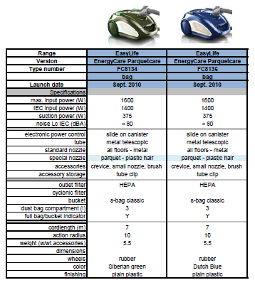

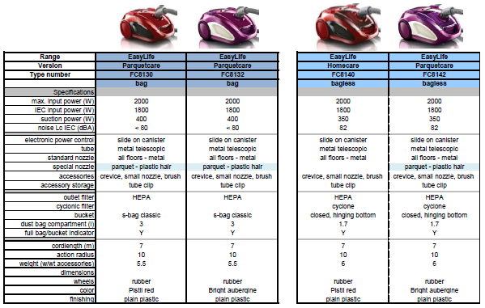

2.2 Product specifications
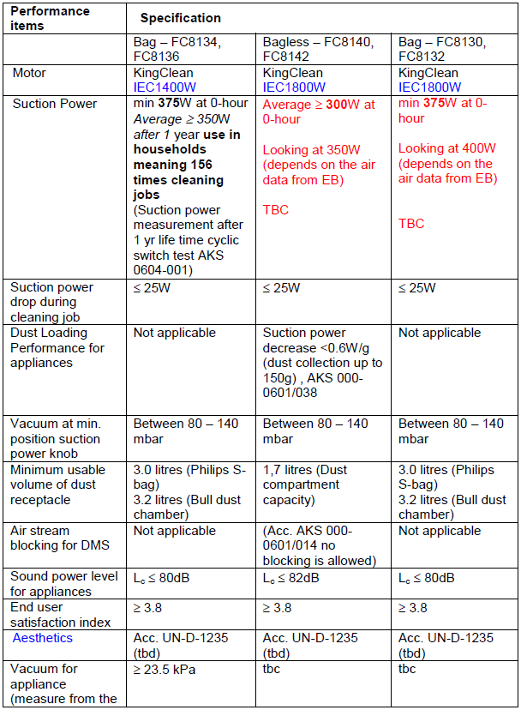

2.3 New commercial features
- The bag type 1600W product should be awarded by green tick logo with the highly efficient motor (1600W input --> > 375W suction power)
- Products need to comply the sustainability requirements of CL

2.4 Commercial Accessories
- FC8070 HEPA Outlet filter
- FC8071 Dust container filter set (HEPA + foam)
- Dust bags FC8021, FC8022, FC8023

3 Architecture and characteristics

3.1 Mechanical
Bagless versions: Bag versions:

3.2 Electrical
220V China:

230V:

3.3 Critical spare parts

- Motor
- PCB
- Cord winder
- HEPA Exhaust filter
- Dust container filterset
- Hose assy
- Tube assy
- Nozzle(s)
- Cone filter
- S-Bag holder

3.4 Consumer replaceable parts

- HEPA Exhaust Filter (FC8070)
- Dust container filterset (FC8071)
- Hose assy
- Tube assy
- Nozzle(s)
- Dust container assy
- Cone filter
- S-Bag holder

4 Cost of non quality prediction

4.1 Call center cost

(Cost per call = average time * cost per minute)
Region | Amount of calls | Total Sales | ACR % | Average call time | Price per minute | Price per call
WE | 1055 | 211K | 0,5 | 10min | € 1 | € 10
APMEA | 165 | 33K | 0,5 | 7min | € 0,20 | € 1,40

- ACR = Amount of calls / total sales

4.2 CPI (Cost per Intervention)
NNP | WE | EE | APMEA
Average retail price (NNP) | € 52.00 | € 52.00 | € 52.00
CPI repair
Additional retail cost's | € 4.00 | € 1.00 | € 1.00
Transportation cost's | € 10.00 | € 7.50 | € 0.00
Repair labour cost | € 11.30 | € 10.00 | € 2.66
Average Discount spares | 30% | 26% | 0%
Sparepart cost's | € 5.62 | € 5.95 | € 8.04
Service concept that will be applied | Carry in repair | Carry in repair | Carry in repair
CPI exchange
Retail transportation cost's? | € 10.00 | € 7.50 | € 0.00
Retail fee | € 5.00 | € 5.00 | € 2.00
Appliance cost's (IIP price) | € 39.00 | € 39.00 | € 39.00
Total repair | € 30.92 | € 24.45 | € 11.70
Total exchange | € 54.00 | € 51.50 | € 41.00

4.3 Predicted Field Quality (PFQ) or Field Call Rate (FCR)

Best estimation at PV is:

FC8134 FC8136: 1.9%
FC8130 FC8132: 2.3%
FC8140 FC8142: 2.3%

4.4 ConQ (Cost of non Quality)
 | CPI repair € | CPI exch. € | Exchange vs repair rate | CPI mix € | FCR | Total sales | CoNQ total
WE | 30.92 | 54.00 | 5% | € 32.08 | 2.33% | 585,000 | € 437,247
EE | 24.45 | 51.50 | 2% | € 24.99 | 2.33% | 207,000 | € 120,516
China | 11.70 | 41.00 | 1% | € 11.99 | 2.33% | 47,000 | € 13,129
Total sales |  |  |  |  |  | 839000
CPI (avg/weighted) |  |  |  | € 29.20
Call center cost Europe |  |  |  |  |  |  | € 29,250
Call center cost APMEA |  |  |  |  |  |  | € 329
CoNQ (Euro) |  |  |  |  |  | Total CoNQ | € 600,141
CoNQ (% sales) |  |  |  |  |  |  | 1.38%

4.5 Fast feedback program

Feedback | regions | Quantity | cost
Rapid exchange Bag version | WE | 50 | € 2500
 |  | Total fast feedback cost | € 2500

5 Consumer care package planning

5.1 Consumer care package

 |  | Yes/No | Accountable | Responsible
In-box
 | User Manual | Yes | ARC | CMM
 | Quick Start Guide | No | ARC | CMM
 | Consumer Care Leaflet | Yes | DFU | CMM
Web
 | Leaflet and Photo's | Yes | DFU/ARC | CMM
 | FAQ's | Yes | ARC | CMM
 | Tips and Tricks | Yes | CMM / Marcom | CMM
 | Instruction movies (tutorials) | no | Marcom | CMM
Call Center
 | Callcenter Scripts and Tips | no | CCQ/ARC | CMM
 | Training package - technical and soft skills | no | CCQ/ARC | CCQ/ARC
 | Training execution | no | CCQ/ARC | CCQ/ARC
 | Product samples | Yes | CMM | CMM
Repair & Exchange
 | Service Manual | Yes | CCQ | CCQ
 | Diagnostics- and Service Tools | no | CCQ | CCQ
 | Service Bill of Material, incl. spare parts Purchasing Master data | Yes | CCQ | CCQ
 | Training package diagnostics & repair | no | CCQ | CCQ

5.2 Special phone number

For Europe 800-number will be added to user manual and quick start guide:
Country | # Type | Consumer  Phone # | date
France | Free phone | 0805025510 | Live
Netherlands | Free phone | 08000230076 | April
Spain | Free phone | 900800655 | Live
UK | Free phone | 08003316015 | April 15
Italy | Free phone | 0800088774 | April 6
Germany | Free phone | 08000007520 | Live

5.3 FAQ (Frequently Asked Questions)
FAQ will be translated in to following languages.

- English, French, Danish, Spanish, Italian, Dutch (for all versions)
- Portuguese (additional for Latam version)
- Chinese Simplified (additional for China version)

Attachment 1: Explanation abbreviations

VPD: Value Proposition Debriefing
AA: Assignment Agreed
PPC: Project Plan Committed
CC: Concept Consolidation
PC: Prototype Consolidation
PV: Product Validated
IR: Industrial Release
CR: Commercial Release
PE: Project end

FSP: Factory Standard Price
IIP: Internal Invoice Price (FSP + NSO costs)

DFU: Direction For Use
FAQ: Frequently Ask Questions
PFQ: Predicted Field Quality
CSO: Consumer Service Offering
ConQ: Cost of non Quality

ACR: Average contact Rate
FCR: Field Call Rate
FAQ: Frequently Ask Questions.

LATAM = Latin America
APMEA = Asian Pacific, Middle East, Africa
Europe = Europe

